**STORE CLOTHES**

**Software Requirement Specification**

**Table of Contents**

I.Overview

1. [Introduction](https://docs.google.com/document/d/1ZH9c_prR1V-4_mXr_OeJM6ZLg5Y1_WOW/edit?fbclid=IwAR0Jpfbk-jSje0W7rU9GVA3r1A1Je8b7b0m0HQLH5e_Ip6iC2nqH5Jyr9CU#heading=h.30j0zll)
2. [System Functions](https://docs.google.com/document/d/1ZH9c_prR1V-4_mXr_OeJM6ZLg5Y1_WOW/edit?fbclid=IwAR0Jpfbk-jSje0W7rU9GVA3r1A1Je8b7b0m0HQLH5e_Ip6iC2nqH5Jyr9CU#heading=h.1fob9te)
3. [Common Requirements](https://docs.google.com/document/d/1ZH9c_prR1V-4_mXr_OeJM6ZLg5Y1_WOW/edit?fbclid=IwAR0Jpfbk-jSje0W7rU9GVA3r1A1Je8b7b0m0HQLH5e_Ip6iC2nqH5Jyr9CU#heading=h.3znysh7)

II. [Functional Requirements](https://docs.google.com/document/d/1ZH9c_prR1V-4_mXr_OeJM6ZLg5Y1_WOW/edit?fbclid=IwAR0Jpfbk-jSje0W7rU9GVA3r1A1Je8b7b0m0HQLH5e_Ip6iC2nqH5Jyr9CU#heading=h.2et92p0)

1

# **I. Overview**

## **1. Introduction**

An online clothing store is a new software system that replaces the current manual and phone processes for ordering and picking up food. The system is expected to grow through multiple issuances, eventually connecting to Internet ordering services for some loca

## **2. System Functions**

## **3. Common Requirements**

# 

# 

# 

# **II. Functional Requirements**

## **1. Feature Common**

### **a. Login**

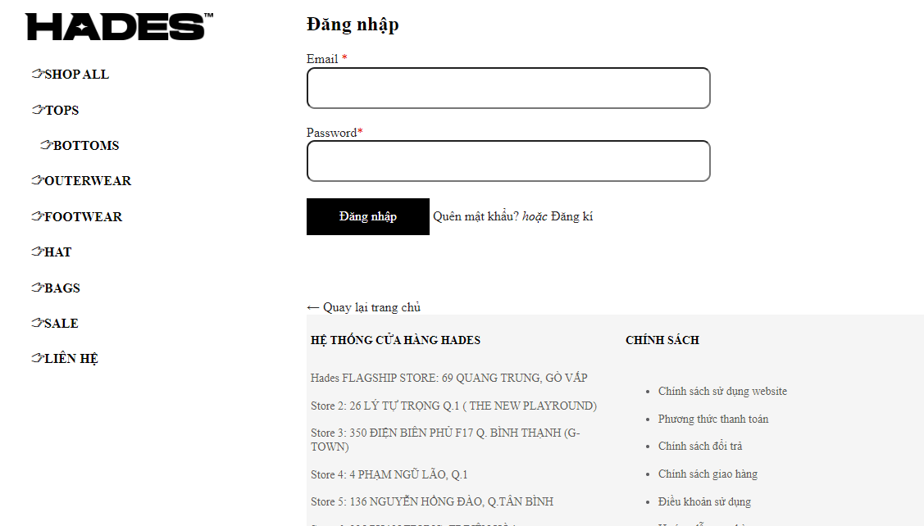

| **UI Element: Login page** | | |
| --- | --- | --- |
| **UI Element Description** | | |
| ID | 2 | |
| Description | The login screen allows the user to log into the system | |
| **UI Element Displays** | | |
| **Precondition** | **Display** | |
| User entered the wrong email | The screen will show the message “Email doesn’t exist” | |
| User entered mail exists in the system but the wrong password | The screen will show the message “Invalid password” | |
| Registered User but not activated account | System will redirect to Verify page | |
| **UI Element Behaviors** | | |
| **Precondition** | **Action** | **Respond** |
| User is not logged in | Input Login URL page in browser | System will redirect to Login page |
| User is logged in | Input Login URL page in browser | System will redirect to Home page |

### **b. Register**

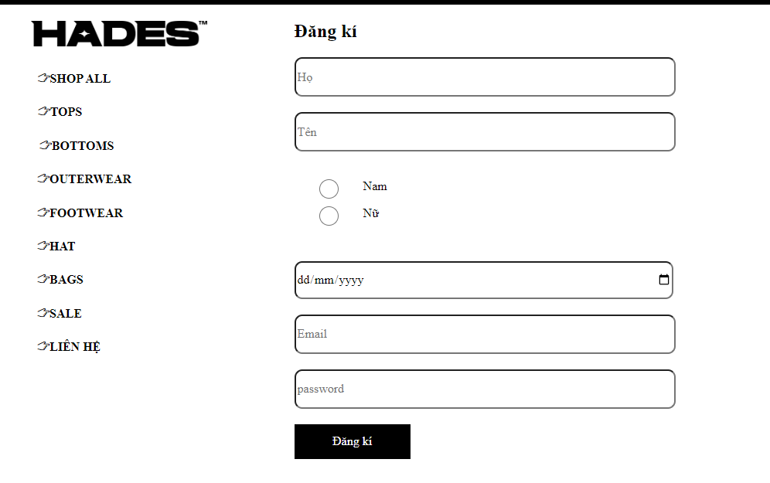

| **UI Element: Register page** | | |
| --- | --- | --- |
| **UI Element Description** | | |
| ID | 3 | |
| Description | The register screen for new account registration users | |
| **UI Element Displays** | | |
| **Precondition** | **Display** | |
| User enters name already used | The screen will show a message “This username is already being used !” | |
| User entered confirm password does not match password | The screen will show a message“Password and Confirm Password must match!” | |
| **UI Element Behaviours** | | |
| **Precondition** | **Action** | **Respond** |
| User not logged in | Input Register URL page in browser | System will redirect to Register page |
| User is logged in | Input Register URL page in browser | System will redirect to Home page |

### 

### **C. Forgot password**

| **UI Element: Reset Password page** | | |
| --- | --- | --- |
| **UI Element Description** | | |
| ID | 3 | |
| Description | Forgot password screen for registered users to get code to get password | |
| **UI Element Displays** | | |
| **Precondition** | **Display** | |
| User entered the wrong email | The screen will show alert “Email does not exist!” | |
| User enters email field, email already exists in the system | System will redirect to VerifyCode Page | |
| User entered the wrong code | The screen will show alert “Verification code is incorrect!” | |
| User enters code field, correct password | System will redirect to GetPassword Page | |
| User entered the wrong Confirm Password | The screen will show alert “Confirm Password is incorrect!” | |
| **UI Element Behaviors** | | |
| **Precondition** | **Action** | **Respond** |
| User input email | Input Register URL page in browser | System will redirect to Forgot Password page |
| User not input email | Input Register URL page in browser | System will redirect to Home page |

### **D. User Profile**

### **F. Change Password**

### 

## **2. Feature public**

### **a. Home**

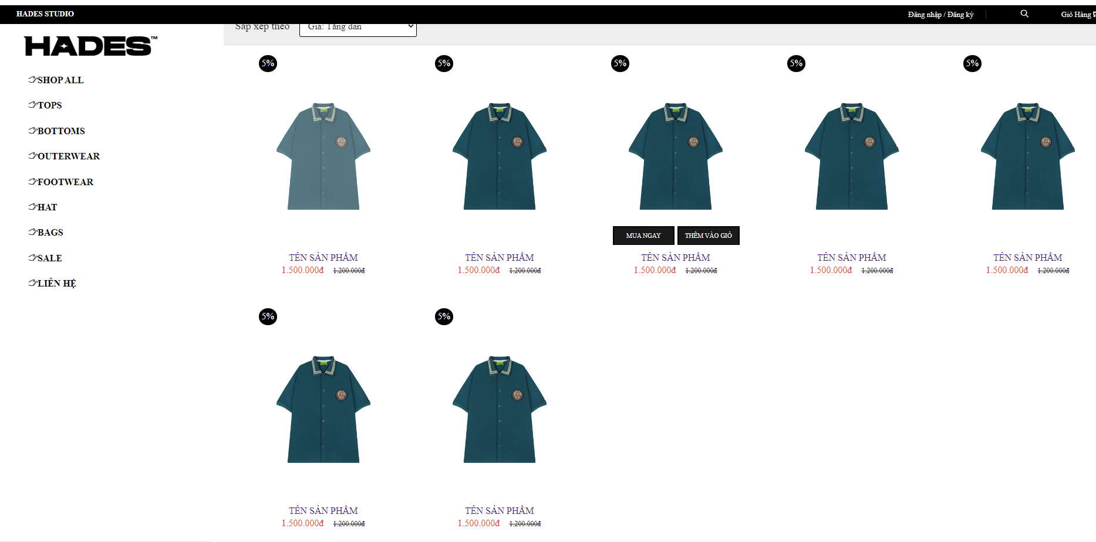

| **UI Element: Home page** | | |
| --- | --- | --- |
| **UI Element Description** | | |
| ID | 7 | |
| Description | This screen shows the home page of the website. | |
| **UI Element Displays** | | |
| **Precondition** | **Display** | |
| Alway | Show Home screen and latest 7 shirts  Button search and textbox search  Home button  Button (element menu)  Back button  Button view | |
| Users not logged in | Screen show button login and register | |
| Users is logged in | Screen show button logout and name user and Button Profile | |

### **b. List clothes**

| **UI Element: Register page** | | |
| --- | --- | --- |
| **UI Element Description** | | |
| ID | 4 | |
| Description | Show all clothing products in the shop | |
| **UI Element Displays** | | |
| **Precondition** | **Display** | |
| Alway | Display all quiz in shop | |
| **UI Element Behaviours** | | |
| **Precondition** | **Action** | **Respond** |

### 

### **c. clothes details**

| **UI Element: Register page** | | |
| --- | --- | --- |
| **UI Element Description** | | |
| ID | 5 | |
| Description | Show detail clothing products in the shop | |
| **UI Element Displays** | | |
| **Precondition** | **Display** | |
| Alway | Display detail quiz in shop | |
| **UI Element Behaviours** | | |
| **Precondition** | **Action** | **Respond** |

### 